**Jmeter- CSV Data Config**

Step1: Add CSV Data Config from Add>>Config element>>CSV Data Set Config

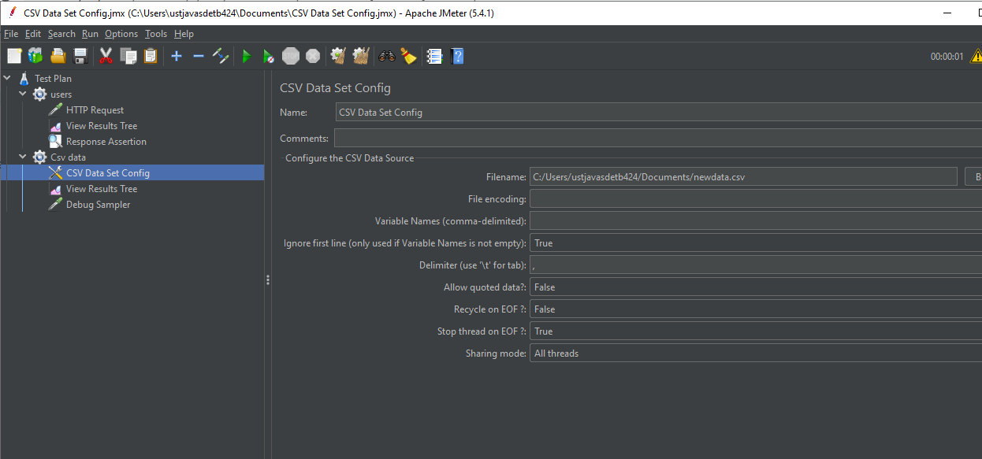

Step2: Add the debug sampler from Add>> Sampler>>Debug sampler

Step3: Add the view REsult tree from Add>> Listener>> View Result tree

Step4: Save and run the threads

